BLAST FROM THE PAST 2020

Celebrating 1970

VENDOR APPLICATION
FRIDAY, JUNE 5 to SUNDAY, JUNE 7, 2020
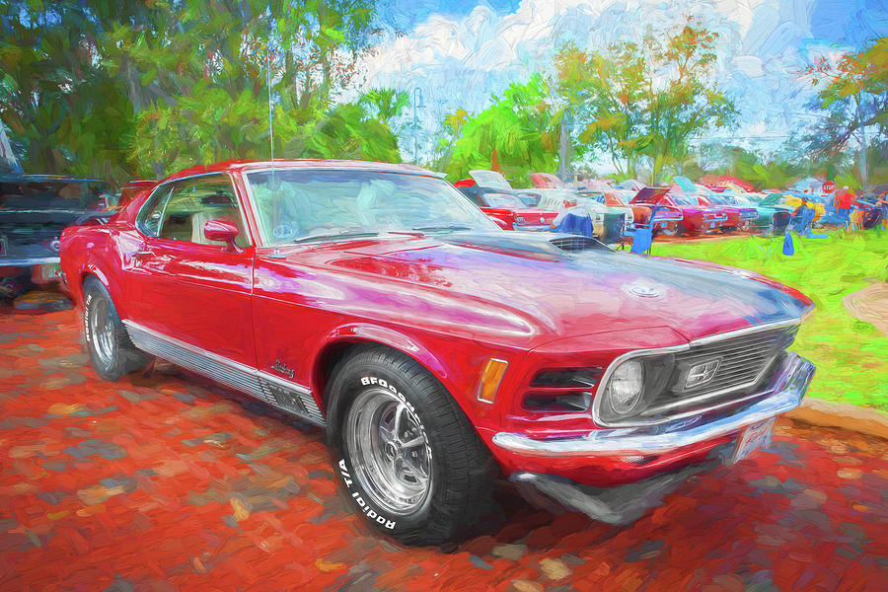
CAR SHOW SUNDAY JUNE 7, 2020

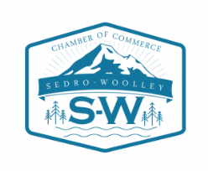

Dear Blast from the Past Vendors,

This year Blast from the Past will be Friday June 5th to Sunday June 7th.

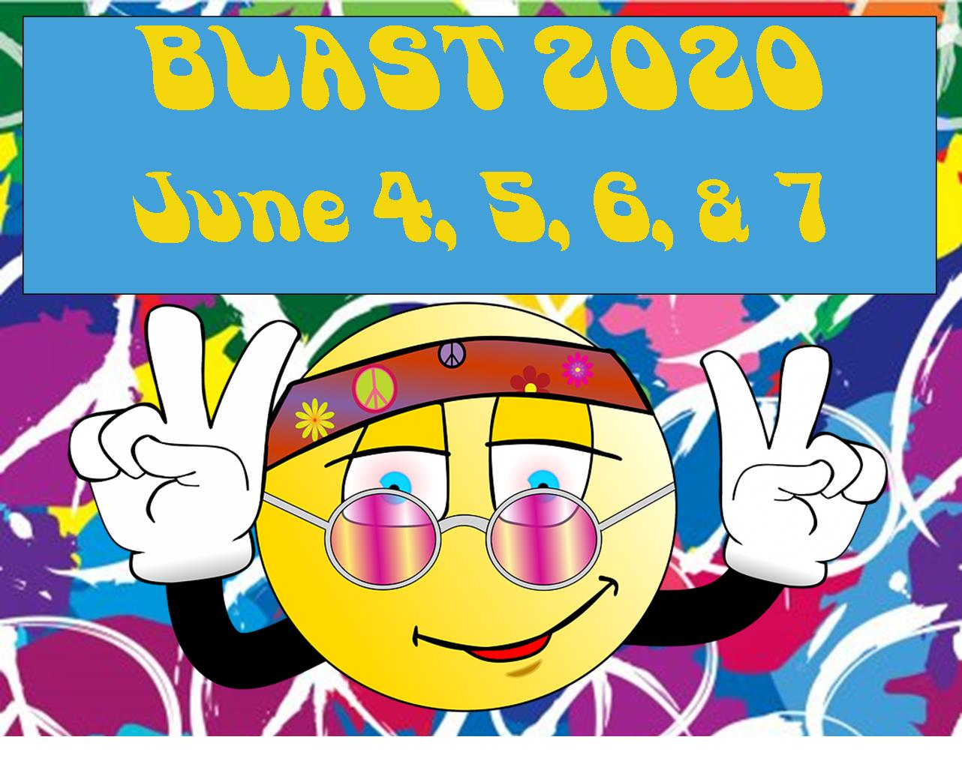

The theme for this year will be “Vintage” 1970. We would like to encourage our vendors to support our theme. If you could have vintage items for sale and/or on display included in your booth that would be greatly appreciated.

We look forward to seeing everyone this June. If you have any questions, please feel free to call or email.

Thank you,

Pola Kelley
Pola Kelley
Blast From The Past
Sedro-Woolley Chamber of Commerce

BLAST FROM THE PAST 2020
The Blast from the Past Committee is again planning our Arts and Craft Show. This year it will again be a three-day event, which will be held on Friday, Saturday, and Sunday - June 5th, 6th, & 7th, 2020 in downtown Sedro-Woolley.
The Sedro-Woolley Chamber of Commerce sponsors this annual show, including Color Run, Arts/Crafts & Food Vendors, Kids’ Contests, Car Show, Music & Beer Garden. We invite you to participate as a Vendor for the three-day show.

WE HAVE MADE CHANGES THIS YEAR!
Craft Booth INFORMATION PAGE - PLEASE READ!
You must initial each of the following to ensure you have read and agree to each of them and return it with your application. Be sure to keep a copy for your records. They must all be initialed for your application to be accepted. Any incomplete applications will be returned/denied. Accepted applications will receive an email confirmation. All Applications are subject to approval by the committee. In instances where an application is denied, payment will be returned.

The booth sizes are Single 12 X 12 ($75), Double 12 x 24 ($150), & Triple 12 x 36 ($225),
Vendors will be lined up on Metcalf Street between Ferry & State Streets and on Murdock Street from Metcalf to Eastern.
___electrical hookup is needed you must be requested IN ADVANCE as they are few and far between. You must provide your own 50 ft. or longer extension cords WITH COVERS. There is a $10 fee for electrical hookups where available. (We will provide a 6’ ladder to reach the light poles)
___You must provide your own booths, display boards, tables, chairs, canopy coverings, etc., for your area.
___You are responsible for completely securing your booth at night (hanging a sheet from your canopy is not considered securing your booth).
___You will be responsible for keeping your area clean at all times.
___We cannot guarantee booths or items will not be duplicated. We will try our best not to place duplicates next to each other, so to help us, you must list your products in detail. Vendors will only be allowed to sell items listed on their applications. In some instances, exclusivity is offered for an additional fee. Please call to see if your business qualifies.
___All vendors are required to park their vehicles in designated parking areas (Not on the Street). FAILURE TO DO SO MAY RESULT IN A TICKET AND BEING TOWED. Parking instructions will be near the maps.
___If you are staying in a trailer overnight, you must stay in designated areas, not on the streets of the event. The city has campsites available in 2 locations
___Please have someone in your booth at all times. (Short meal & break closures ok).
___Each vendor will be responsible for conducting their own sales and collecting their own sales tax. We encourage you to plan your booth, so you can operate the full three days. If you cannot attend all three days, you will not be able to attend.
___Inclement weather will be monitored closely, and the committee will notify vendors of early closures.
___This is a family friendly event and any item deemed inappropriate by the committee must be removed upon request.
___Security will be on site from 7pm to 7am Friday and Saturday nights.
___Maps will be available in front of the Chamber on Friday morning. Please do not call beforehand to get your booth location.
___I WILL BE RESPONSIBLE for providing my own tables, chairs, and canopy, setting up my own booth and cleaning up my area immediately following the show. I am also aware that my booth fee is NON-REFUNDABLE (except if a corner booth is not available, then the additional fee will be returned).

SETUP TIMES AND HOURS OF OPERATION
Thursday Night Music Indoor Venue to be announced

Friday setup: from 7:00 AM - 12:00 NOON Show runs 12:00 NOON – 7:00 PM
You must be set up by noon on Friday or you will not be able to attend at all during the weekend!

Saturday Show runs 9:00 AM – 7:00 PM

Sunday Show runs 9:00 AM – 4:00 PM Teardown begins at 4:00 PM
You must have the street cleared by 6:00pm!
Late opening or Early departure are not allowed and WILL result in being denied future participation in the Blast from the Past event.

Booth footprint sizes are as follows: / 12 X12 $75 / 12 X 24 $150 / 12 X 36 $225

CORNER spot (these are very limited & will be assigned on a 1st come basis) Extra charges do apply.
A single corner 12x12 North to South is $50, a Double Corner 12x24 East to West constitutes two corners & is $100.

Use of electrical outlet is an additional $10.

Due to problems with sidewalk booths in the past, there will be no commercial use of sidewalks
Nonprofits like hospital guilds and scouts will be reviewed on a case by case basis.

BLAST FROM THE PAST 2020 -- CRAFT VENDOR APPLICATION

I wish to participate in the BLAST FROM THE PAST Show as a CRAFT Vendor.
Friday, June 5th, from 12 noon to 7:00PM, Saturday, June 6th, from 9AM – 7:00PM, and Sunday, June 7th, from 9:00AM – 4:00PM. Members of the Chamber have priority over non-members.

BUSINESS NAME: _______________________________________________ Contact Name:___________________

E-mail Address: _______________________________________________________Phone # __________________

Address:______________________________________________________________________________________

Type of Crafts/Arts (please add additional pages as needed): __________________________________________________________
____________________________________________________________________________________________________________
____________________________________________________________________________________________________________
____________________________________________________________________________________________________________

Pictures included: _____ Yes _____ No Vintage items: _____ Yes _____ No

If you have a special request for booth placement, please let us know. Requests will be accommodated on a first come first serve basis, no vendor should assume that where they were before is automatically going to be theirs again. No assumptions should be made regarding our knowledge of prior year’s placement as a primarily volunteer organization we do our best, but it is up to the vendor to contact us regarding preferred locations. Exclusivity is available for a fee. Please call ahead to see if you qualify for exclusivity.
Choose Booth Size First:
Booth size (footprint): [ ] 12 X12 ($75) [ ] 12 X 24 ($150) [ ] 12 X 36 ($225) Booth Cost _______________
For an additional cost you can add:
CORNER spot (total of 16 corner spots are first registered, first served)
[ ] $50 Single corner 12x12 booth North to South OR
[ ] $100 Double corner 12x24 booth two corners East to West Corner Cost _______________

Electrical hook up [ ] $10 extra Electrical Cost _____________

Exclusivity [ ] $50 extra Exclusivity Cost_____________

LATE APPLICATION FEE (you must call to see if we can still accommodate you) Last year we filled up fast and we are looking to expand the use of thestreets but you may not be accepted if your app is turned in late. Must be turned in by May 24th, 2020.

$25 Late Fee ______________
Added Costs _______________
Total Payment enclosed: $______________________________
BLAST FROM THE PAST 2020
INDEMNITY AGREEMENT
RETURN completed application & Indemnity
no later than May 24, 2020
to
Sedro-Woolley Chamber of Commerce,
810 Metcalf Street, Sedro-Woolley, WA 98284
Make Checks payable to: Chamber of Commerce – Blast from the Past
Or you can pay online at www.sedro-woolley.com with your credit card

EMAIL___________________________________________________________________CELL PHONE__________________________

BUSINESS NAME______________________________________________________________________________________________

OWNER NAME________________________________________________________________________________________________

ADDRESS____________________________________________________________________________________________________

CITY__________________________________________________________________STATE ______________ ZIP _______________

I have read and understand all the foregoing Rules and Regulations.
To the fullest extent permitted by law, Contractor shall indemnify, defend and hold harmless the Sedro-Woolley Chamber of Commerce, City, agencies of the City and all officials, agents and employees of State, from and against all claims arising out of or resulting from the performance of the contract. “Claim” as used in this agreement means any financial loss, claim, suit, action, damage, or expense, including but not limited to attorney’s fees, attributable for bodily injury, sickness, disease or death, or injury to or destruction of tangible property including loss of use resulting there from. Contractor’s obligation to indemnify, defend, and hold harmless includes any claim by Contractor’s agents, employees, representatives, or any subcontractor or its employees.

Contractor expressly agrees to indemnify, defend, and hold harmless the Sedro-Woolley Chamber of Commerce and the City for any claim arising out of or incident to Contractor’s or any subcontractor’s performance or failure to perform the contract. Contractor shall be required to indemnify, defend, and hold harmless the Sedro-Woolley Chamber of Commerce and the City only to the extent claim is caused in whole or in part by negligent or intentional acts or omissions of the City. I have all permits, licenses, insurance, etc. required by the city, county, and state to operate a legal business. I am of legal age (18 years or more).

In consideration for allowing me to participate, I agree to indemnify and hold harmless the Sedro-Woolley Chamber of Commerce and their agents, the City of Sedro-Woolley and their agents, from expenses of whatsoever kind or nature, including attorney’s fees, incurred by reason of or in connection with participation in this event.

Businesss Owner Signature Date

____________________________________________________________________________________________________________

CONTACT PERSON FOR EVENT (if different from above)_______________________________________________________________

Cell Phone #_______________________________________________ Email______________________________________________

